17.67: (Although it may be easier for some to solve for the heat flow per unit area, part (b), first the method presented here follows the order in the text.) a) See Example 17.13; as in that example, the area may be divided out, and solving for temperature at the boundary,

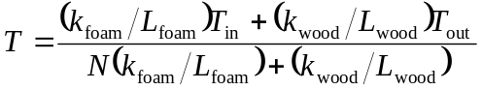

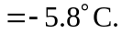

Note that the conversion of the thickness to meters was not necessary. b) Keeping extra figures for the result of part, (a), and using that result in the temperature difference across either the wood or the foam gives

